JSON Structure

🌟 What is JSON Structure?
# Source: AI Source: Provided by: [Data Path: Persons Table -> ID Column: 1, Name_En Column: Motasem Essam] -> From: [ChatGPT] on [5/31/2026]
JSON Structure refers to the way data is organized inside JSON using:
- Objects { }
- Arrays [ ]
- Key–value pairs
It defines how information is written and nested.

🧱 JSON Structure Types

🔑 1. Key–Value Pairs
# Source: AI Source: Provided by: [Data Path: Persons Table -> ID Column: 1, Name_En Column: Motasem Essam] -> From: [ChatGPT] on [5/31/2026]
JSON is built using keys and values.
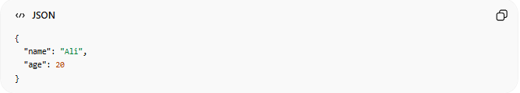
{
"name": "Ali",
"age": 20
}
- "name" → key
- "Ali" → value

🧱 2. JSON Objects { }
# Source: AI Source: Provided by: [Data Path: Persons Table -> ID Column: 1, Name_En Column: Motasem Essam] -> From: [ChatGPT] on [5/31/2026]
An object groups related data.
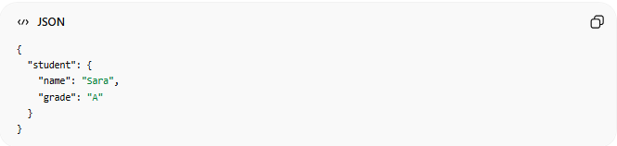
{
"student": {
"name": "Sara",
"grade": "A"
}
}
👉 Objects can contain other objects (nested structure)

📚 3. JSON Arrays [ ]
# Source: AI Source: Provided by: [Data Path: Persons Table -> ID Column: 1, Name_En Column: Motasem Essam] -> From: [ChatGPT] on [5/31/2026]
An array is a list of values.
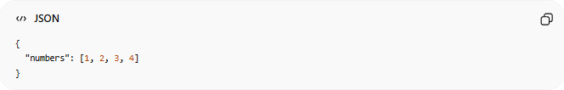
{
"numbers": [1, 2, 3, 4]
}

Array of objects example
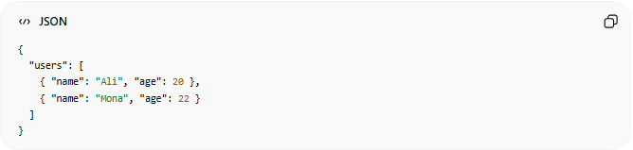
{
"users": [
{ "name": "Ali", "age": 20 },
{ "name": "Mona", "age": 22 }
]
}

🔄 4. Nested JSON (Very Important)
# Source: AI Source: Provided by: [Data Path: Persons Table -> ID Column: 1, Name_En Column: Motasem Essam] -> From: [ChatGPT] on [5/31/2026]
JSON can contain objects inside objects inside arrays.
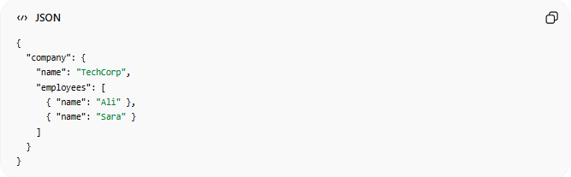
{
"company": {
"name": "TechCorp",
"employees": [
{ "name": "Ali" },
{ "name": "Sara" }
]
}
}

🧩 5. Mixed Structure
# Source: AI Source: Provided by: [Data Path: Persons Table -> ID Column: 1, Name_En Column: Motasem Essam] -> From: [ChatGPT] on [5/31/2026]
JSON can combine everything:
- Objects
- Arrays
- Multiple levels

⚠️ JSON Structure Rules
# Source: AI Source: Provided by: [Data Path: Persons Table -> ID Column: 1, Name_En Column: Motasem Essam] -> From: [ChatGPT] on [5/31/2026]
- Keys must be in double quotes
- Data must follow correct format
- No functions allowed
- No comments allowed
- Must be valid hierarchy

🧠 Simple Idea
# Source: AI Source: Provided by: [Data Path: Persons Table -> ID Column: 1, Name_En Column: Motasem Essam] -> From: [ChatGPT] on [5/31/2026]
Think of JSON structure like:
📦 A box inside a box system
- Object = box
- Array = list of boxes
- Nested = boxes inside boxes

🔗 Real API Example
# Source: AI Source: Provided by: [Data Path: Persons Table -> ID Column: 1, Name_En Column: Motasem Essam] -> From: [ChatGPT] on [5/31/2026]
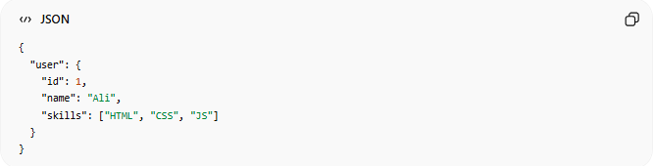
{
"user": {
"id": 1,
"name": "Ali",
"skills": ["HTML", "CSS", "JS"]
}
}

🧭 Summary
# Source: AI Source: Provided by: [Data Path: Persons Table -> ID Column: 1, Name_En Column: Motasem Essam] -> From: [ChatGPT] on [5/31/2026]
JSON structure defines how data is organized using objects, arrays, and nesting, allowing complex information to be stored and transferred in a clear, readable format.

